Overview [ReviewSentinel]
Review Sentinel is an end-to-end machine learning-driven project designed to detect and flag computer-generated fake product reviews, ensuring authentic customer feedback and maintaining the integrity of online reviews.

Setting up the environment
conda create -n reviewsentinel python=3.9
pip install ipykernel pandas scikit-learn numpy nltk matplotlib beautifulsoup4

Results Reproducibility
- For train-val-test split, use ‘StratifiedShuffleSplit’ with random_state=72

Data Profiling: EDA, Preprocessing & Baseline
Based on data profiling, train-test-val split is getting created with even representation across all the ratings so as to be able to train and test on reviews that are from different ratings. Total rows in original reviews data is ~40000 and the split ratio for train-test-val is 80%:17.5%:2.5%.
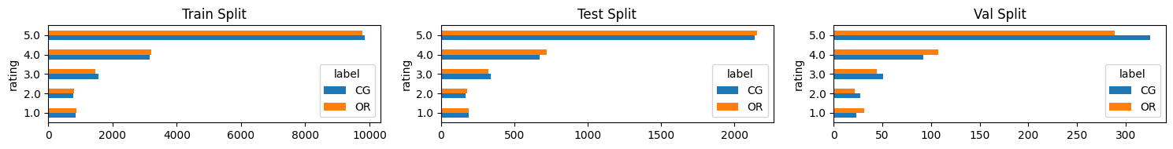
After preliminary EDA, two versions of pickle files are being created for the review data in jupyter notebook, one with just cleaned text and another with tf-idf features. For tf-idf vectorization, only words that have occurred in more than 0.5% and less than 99.5% of the reviews are being considered. These percentages were selected to make sure I have good enough features to work with and be able to find it in new reviews as well.

